Self Portrait With A Beret  Claude Monet | 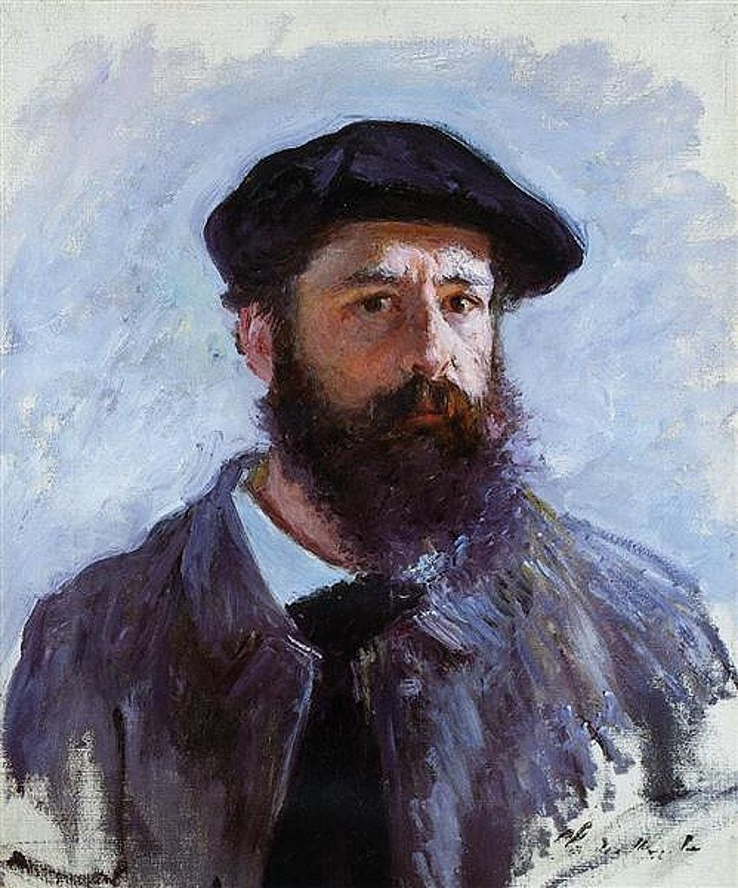
ㅡ  Why did you select it? | I over all like Monet as a painter, so I remembered his famous self-portrait and decided to analyze it. It doesn’t stand out too much, portrait is calm, but that what I find the most interesting to me. With visual brush strokes, unfinished bust, yet amazing depiction of the use of light in painting Monet created portrait of himself.
ㅡ  Theme and Tone | The main emotion of the piece is seriousness, this portrait is mostly created to depict artist, maybe to leave behind information how they looked like. There is a distinct twinkle in his eyes, despite the serious expression represented by a slightly furrowed brow.
ㅡ  Technique | Fervent strokes of numerous colours represent the creased fabric of the overcoat. Much smaller brushstrokes are used to depict his textured beard, which one can almost imagine reaching out and touching.  This painting is considered an Impressionist style of art, wherein the perceptions of the subject are conveyed by the artist, rather than the painting being a specific and accurate likeness. Often described as the 'driving force behind Impressionism', Monet's paintings were always characterised by an exquisite appreciation of light and colour.  He particularly enjoyed experimenting with colour and was fascinated by how things looked at different times of day with the changing light. His portraits not only portrayed figures but also beautifully captured the atmosphere.
ㅡ
Last thoughts
 | I always recommend Monet, when someone asks about inspirational material in a world of an Impressionist art. I have problem till this day with light in my artworks, and colour as well. I like the messiness of his portrait, as well as clear emphasis on the face. Artist knows how to manipulate with the eyes of viewers, purposely directing them to the most important objects. There is also good use of both cold and warm colours, which I still try to accomplish.

